
Year 10 Science 2021 Name: __________
Biology 1 Test: Inheritance

SECTION 1: MULTIPLE CHOICE (1 mark each)
Circle your answer on the multiple choice answer sheet.

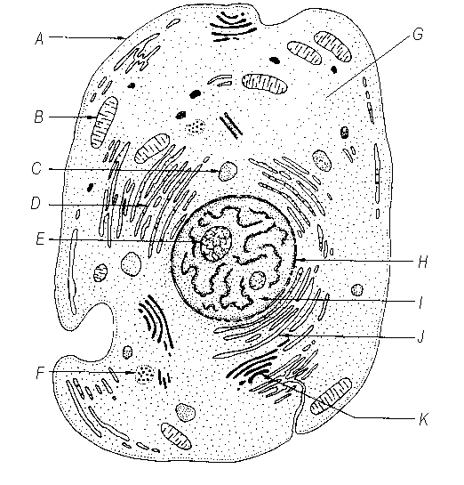
The part of the cell that is labelled I is the
  - nucleolus
  - nucleus
  - nuclear membrane
  - cytoplasm

- Which of the following structures are made out of DNA?
  - chromosomes
  - chloroplasts
  - cell membranes
  - mitochondria

- How many different bases make up the “genetic alphabet” of DNA?
a) 2
b) 3
c) 4
d) 5

- What shape is a DNA molecule?
a) X shaped
b) Double helix, like a twisted ladder
c) Star shaped
d) Arch shaped, like a rainbow

- Which of the following statements is incorrect about chromosomes?
  - Chromosomes are made of DNA.
  - Chromosomes are found in the nucleus.
  - Chromosomes contain genes for inheritance.
  - Chromosomes are always visible under a microscope in stained cells.

- Which of the following is correct about asexual reproduction?
  - It results in greater diversity than sexual reproduction.
  - The offspring are all identical to their parents.
  - It involves two parents.
  - It only occurs in bacteria and single celled organisms.

The next three questions refer to the diagrams below, which are microscopic photographs of a cell at various stages of mitosis.

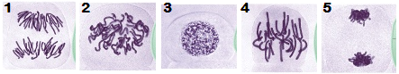

- The correct sequence for these stages is
- 1,2,3,4,5
- 3,2,5,4,1
- 3,2,4,1,5
- 2,5,4,1,3

- Diagram “1” shows which phase of mitosis?
  - Interphase
  - Prophase
  - Metaphase
  - Anaphase

- During which phase does replication (copying) of DNA occur?
  - Interphase
  - Prophase
  - Metaphase
  - Anaphase

- The process that produces gametes (eggs, sperm and pollen) is called
  - mitosis.
  - meiosis.
  - cloning.
  - fertilisation.

- A sudden change in genetic make-up that results in a new characteristic which is inheritable is called a
  - multiple allele.
  - lethal factor.
  - mutation.
  - chromosome.

- Two black dogs may have black or brown pups, but two brown dogs will only have brown pups. This is because
  - black colouring is dominant to brown colouring.
  - black colouring is recessive to brown colouring.
  - black and brown colouring are co-dominant.
  - black colouring is more common in dogs.

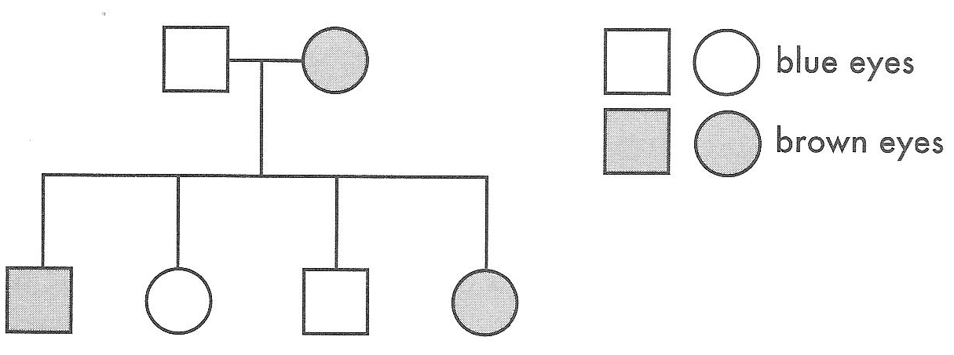
13.

If brown is dominant to blue, which of the following is possible?
- the mother is homozygous and the father is heterozygous for eye colour
- the father is homozygous and the mother is heterozygous
- the father and mother are both homozygous
- the father and mother are both heterozygous

- In humans, sex is determined by one pair of chromosomes out of the 23 pairs. Females are
  - XX
  - XY
  - YX
  - YY

- Sex-linked recessive characteristics like red-green colour blindness and haemophilia are more common in
  - males
  - females
  - homozygous individuals
  - individuals with extra chromosomes

- The genetic code for an individual for a particular trait is called
  - allele
  - genotype
  - phenotype
  - a punnet square

- Mutations caused by insertion or deletion of one or more bases cause the information following it to be jumbled so that it cannot be read to make a protein. These types of mutations are called
  - silent
  - misssense
  - nonsense
  - frameshift

- In budgerigars, green feather colour (G) is dominant to blue feather colour (g). Two heterozygous green budgerigars are mated, what are the most probable phenotypes of the offspring?
  - All the offspring will be green
  - All the offspring will be blue
  - The offspring would be 50% green and 50% blue
  - The offspring will be 75% green and 25% blue

- Cells present in new embryos for a few days after fertilisation, which are capable of becoming any type of cell in the body are called
  - plasmids.
  - Modifiers.
  - stem cells.
  - Carcinogens.

- Which of the base sequences below would pair with the following DNA strand?

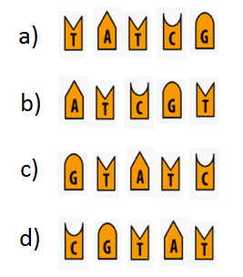
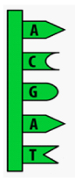
SECTION 2: WRITTEN
Write your answers in the spaces provided. Show all working.

- In mice, black fur is dominant to brown fur. Predict the possible genotypes and phenotypes of the offspring if a homozygous black male was crossed with a homozygous brown female.

Key: (1)

Parent’s Genotype: (1)

Punnet square working out: (1)

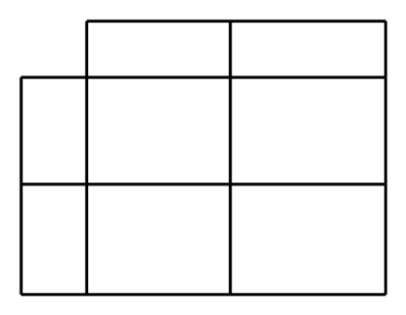

Offspring Genotypes: (1)

Offspring Phenotype: (1)
- Fur colour in mice is controlled by a single gene, which is expressed as either white or grey. The pedigree below shows fur colour.

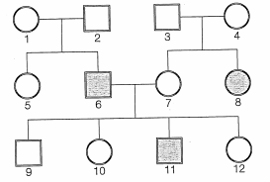

- Complete the key by drawing in the symbols (4)

 | 
 | 

- Based on the pedigree above, is white fur or grey fur dominant? Use a punnet square as evidence to support your choice. (2)

- Look at the pedigree chart and answer the questions below.
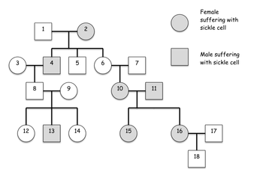
- What is the relationship between 2 and 4? |  | (1 )
- How many children did 8 and 9 have? |  | (1)
- Is this condition dominant or recessive? |  | (1)
- What is the genotype of 2? |  | (1)
- What is the probability of 8 and 9 having another child with sickle cell? Use the punnet square to show your working.  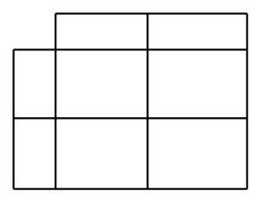 |  | (3)

- State one argument for and one argument against the use of genetically modified crops

(2)
END OF TEST (OUT OF 40 MARKS)

